How to Reset Password

Step 1: Login to Mede-care.
Step 2: Click on Settings Facility Employee User set up Select The User you want to Change password.
Step 3: Check off option Display on Screen and Click on Reset Password.
Step 4: Copy new Temporary password.
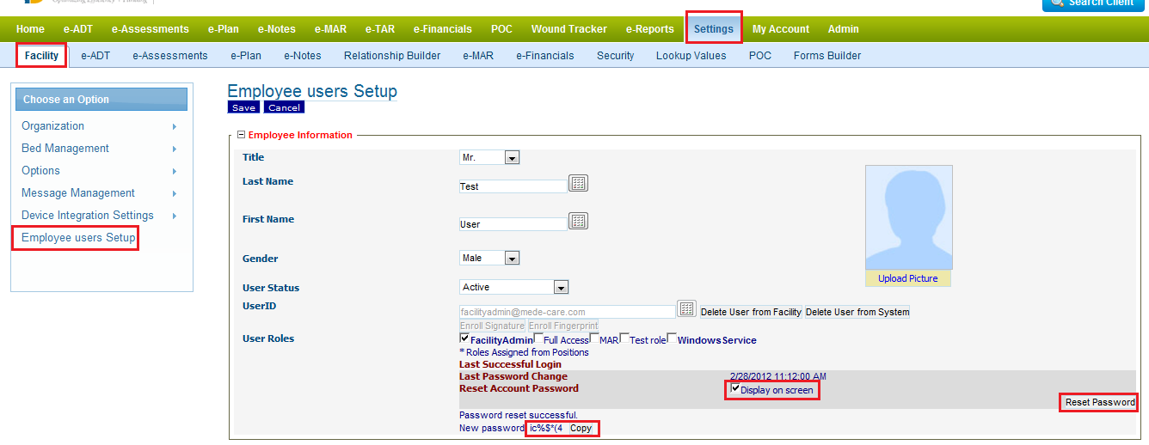

Step 5: When User Logged in with Temporary password they should be able change the password.

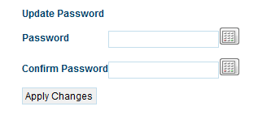
Step 6: Apply changes and password should be changed.

