Below are the directions to run a VAR (verification audit report) from the new CCRS system.

1. Navigate to CIHI Website [www.cihi.ca](http://www.cihi.ca)

2. Select Applications (located on the top portion of the screen)

3. Select “Operational Reports”

4. Log into your personal Client Services account

5. In **Operational Reports – CCRS Reports**, click on the “Create Report” tab and then select “Create Verification Audit Report – Production.”

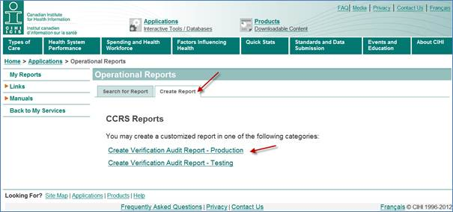

6. Next you will be brought to a screen where to enter parameters for the VAR creation.

7. Select the appropriate facility (if there is more than one listed)

8. Enter the parameter to search by:

1. Start date and End date
2. File Name
3. Record Type
4. Unique Record ID
5. Health Record Number
6. Unique Registration Identifier

Note: Not all fields are required to run the search, a search can be based on File Name only, or start and end date only.

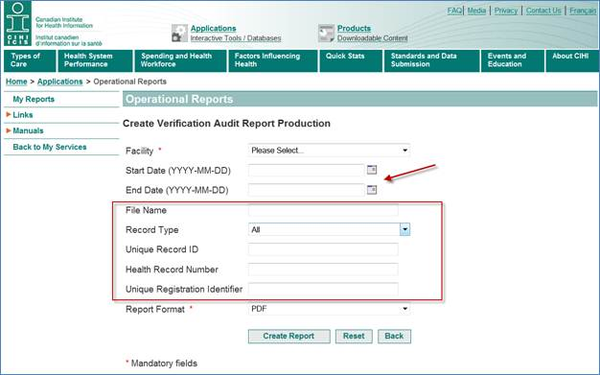

9. Click the “Create Report” button and wait for your VAR to be produced… usually within a minute or two.