CHANGE REQUEST

Instructions: Please refer to the sample attached when completing this form. We greatly appreciate your suggestions and recommendations. We will create a ticket for this request which will be reviewed by our Change Control Board.

Requested by: |  | Position:
Facility: |  | Tel: |  | Ext:
What is your request?

What is the purpose of this request?

Who will be affected by this change?

What version of the software do you have? | Which module of the software? |  | Which section of the module?
Describe your recommendation (Feel free to attach screen shots, diagram, charts, etc.):

Signature: _______________________________________________________ Date: __________________________

CHANGE REQUEST
(SAMPLE)

Instructions: Please refer to the sample attached when completing this form. We greatly appreciate your suggestions and recommendations. We will create a ticket for this request which will be reviewed by our Change Control Board.

Requested by: Mary Smith |  | Position: RAI-Coordinator
Facility: Montecasino Long Term Care |  | Tel: 555-5555 |  | Ext: 321
What is your request? A New Report

What is the purpose of this request? We need a report on medication orders based on type e.g. antipsychotic, hypoglycemic agents, etc.

Who will be affected by this change? Physicians, Management, Care Teams

What version of the software do you have?  407.6 | Which module of the software?  Reports |  | Which section of the module?  Medication
Describe your recommendation (Feel free to attach screen shots, diagram, charts, etc.):

The report:
- can be generated by unit and by physician
- will show details of the medication order
- will show the total by medication type, by resident, by unit, and by facility
- comparison from a previous quarter

Signature: _______________________________________________________ Date: __________________________

Example suggestion
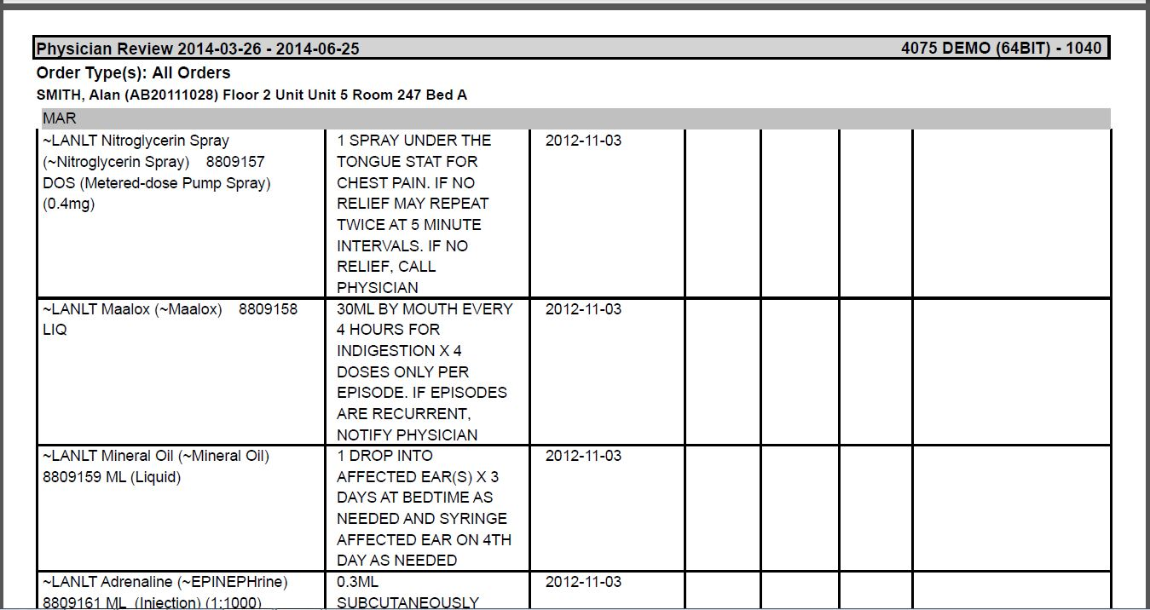
Include column titles

